Table of Contents

Background 2

Issues with the Current System 2

Vision 3

Stakeholders 4

Cost 4

Business Rules 4

Downside 5

Appendix A 6

Glossary 6

Appendix B 7

Stroom: Study Room Reservation System

# Background

A few years ago, the Fort Bend County Library System (FBCL) changed its mission statement. One of the three major areas of service FBCL has identified is serving as independent learning center by functioning as a hub of community and cultural activities. The FBCL realizes this goal by providing study rooms in eight of its twelve branches (including Sienna Branch Library).

With the new access of study rooms, the library’s policy and procedures were updated and a spreadsheet was created. This spreadsheet keeps tracks of the rooms being used, how many people used them, and the duration of the room usage. Study rooms are provided by the Adult Reference staff and can be used by anyone whether they are member or not of the library.

# Issues with the Current System

As mentioned before, an Excel spreadsheet (see Figure 1 in **Appendix B**) was created to keep track of the study room usage. This spreadsheet can only be managed by one staff member since the spreadsheet is stored in a flash drive. This condition raises a problem when the reference desk is swamped with multiple patrons asking for a study room and only one person can provide information.

In addition of keeping data of the study rooms’ usage, the spreadsheet is also used to keep track of a room called Distance Learning Room. This room is used for proctored tests. Only the Department Manager can check-in/check-out people from this room, which can cause some inconvenience if the manager is not present at the reference desk.

Because study rooms are limited, implementing a first-come, first-serve system was essential (see Figure 2 in **Appendix B**). This policy prevents patrons from hoarding a study room. As stated by the Study Room Policy, patrons have two hours guaranteed per day, which means they can only use a study room once per day. Since we only keep first names in the people can have the same first name.

Furthermore, the current spreadsheet does not facilitate the elaboration of statistics. Thus, there is no way the library can keep track if the study rooms do comply with the library’s mission to a space for study and collaboration.

# Vision

The main goal of Stroom is to provide a secure database that can be accessed several staff member and keep data integrity. Uniformity and consistency are the motivation behind Stroom. Besides steadiness, Stroom will help provide information if the the study are being used correctly and if they meets the library’s mission.

In the future, further improvements to Stroom would be converting the database into a web-application so students can book the study rooms online. Nevertheless, with the constraints of time and knowledge, converting the spreadsheet into a database is the goal.

# Stakeholders

Librarians, paraprofessionals, and library assistants will be directly benefited from this database. They can keep track of the rooms used and who are using them. The branch manager will also be benefited since he can include in his quarterly a report of the use of the study rooms. Furthermore, Stroom can also be helpful for patron. Even though patrons will not be allowed direct access to the database, the library administration can renovate the study rooms (by adding white boards, audiovisuals, etc.) with the tracking of Stroom.

# Cost

For the moment, Stroom and any application used to develop Stroom are free of cost.

# Business Rules

The business rules by which the database is confined are the following:

|  |  |
| --- | --- |
| **Entity** | **Attribute** |
| Room | RoomID*  RoomNum [ru]  MaxOccupants [r]  Occupants [r]  TotalPeople [r]  TotalHours [r]  Description |
| Activity | ActivityID*  Reason [r]  ApprovalStatus [r]  Duration [r]  UserStatus [r]  *RoomID [r]*  *StaffID [r]* |
| SignIn | *RoomID [r]*  *StaffID [r]*  *AVID [r]* |
| User | UserID*  FirstName [r]  LastName [r]  IDForm [r]  UserStatus [r]  TimeIn [r]  TimeOut [r]  WarningAd  *RoomID [r]* |
| Staff | StaffID*  FirstName [r]  LastName [r]  Position [r] |
| AV | AVID*  AVEquipment [r]  *RoomID [r]*  *StaffID [r]* |
| **Relationships (see Figure 3 in Appendix B)** | |
| A User can reserve only one Room per day. A Room can be occupied by many Users.  A Room can be used for one activity at the reserved moment. An activity can be carried out at many rooms.  A Room can have none or many Audiovisual (AV) equipment. AV equipment can be placed in many Rooms.  A Staff member can manage multiple rooms. A Room can be managed by multiple Staff members. | |

# Downside

While there are many advantages of transitioning from spreadsheet to database, databases generally require a higher level of technological expertise. Most of the library staff is not technological savvy. Therefore, a proper training most be offered in order for Stroom to be successful.

# Appendix A

## Glossary

**AV:** refers to audiovisual devices like computers, projectors, microphones, etc.

**Fort Bend County Library System (FBCL):** public library system serving the county of Fort Bend, Texas.

**Sienna Branch Library:** one of the eleven library branches of the FBCL.

# Appendix B

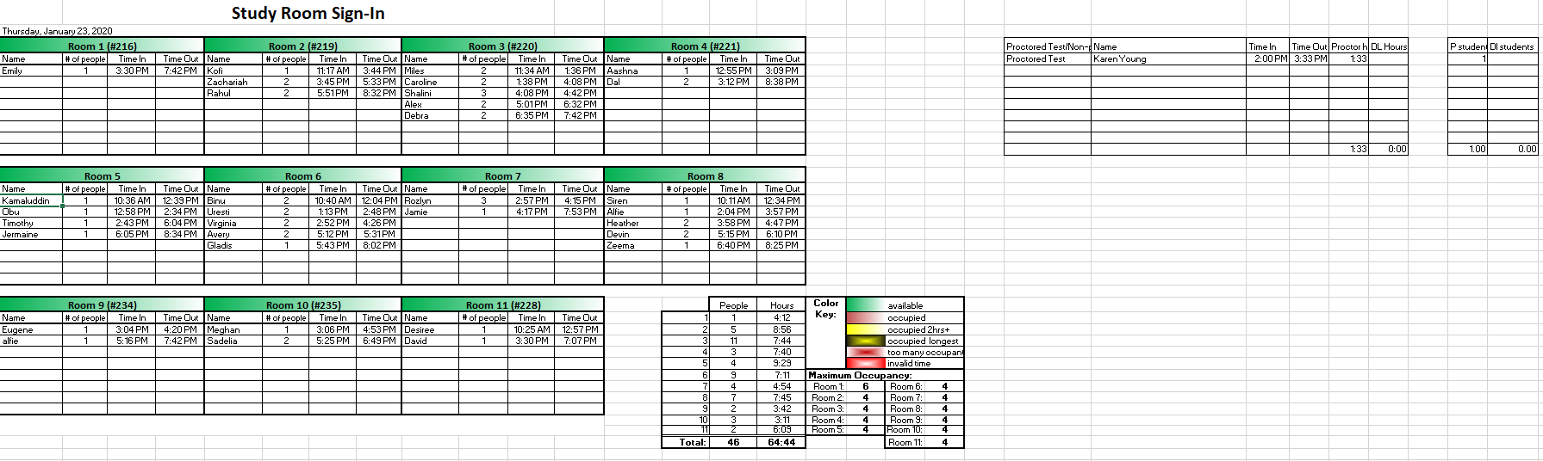

**Figure 1** Screenshot of the current spreadsheet which keeps track of the study rooms.

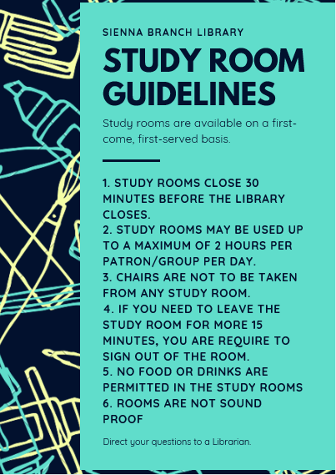

**Figure 2** Flyer with the library’s policy for study rooms.

**Figure 3** Logical model for Stroom’s database.